Arduino Microcontroller Board with Labview

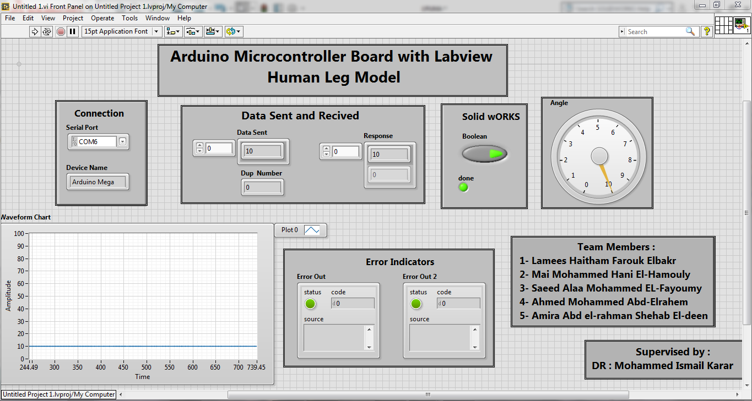 Human Leg Model

**Supervised by :**

**DR : Mohammed Ismail Karar**

**Objective :**

Designing a **simulation** system **for robotics** system for rehabilitation.

**Rehabilitation robotics** includes development of robotics devices for assisting patient.

Our **system** will aid the **patient** with **flexion deformity of knee** where they have inability to fully straighten their knee.

System Description :

The Block Diagram for any closed loop system is :

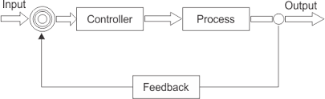

**For our system :**

**Input** : desired torque ( Equivalent voltage )

**Controller** : PID controller based on Arduino

**Process** : Human Leg Mechanical Joint

**Output** : leg angle

**The system is divided into 5 parts :**

**1- Modeling** : implementation of mathematical model for human leg ( simulated in labview )

**2- controller** : designing pid controller based on Arduino.

**3-Simulation** : system simulation with controller on solidworks

**4- communication & GUI** : connection between labview and Arduino and simulation GUI

**5- Hardware** : LCD interface to display output

Let's start to introduce our system in details :

**For Modeling**

**System parameters :**

**T** : Applied Torque by muscles

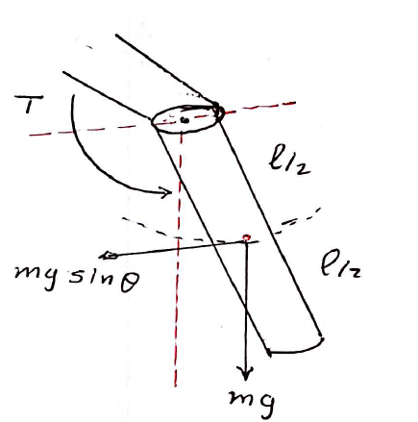**D** : Viscus Friction of the junction

**L** : Length

**m** : mass

**J** : inertia $J=m*g* \frac{L}{2}$

**Model transfer function :**

$$J ӫ+Dӫ+ \frac{L}{2} mg sin\left(ө\right)=T$$

Linearizing Sin($ө$) around $ө=0$

$$J ӫ+Dӫ+ \frac{L}{2} mgө=T$$

Applying Laplace transform

$$J s^{2}ө+Dsө+ \frac{L}{2} mgө=T$$

$$ө (J s^{2}+Ds+ \frac{L}{2} mg)=T$$

$$\frac{ө}{T}= \frac{1}{ J s^{2}+Ds+ \frac{L}{2} mg}$$

let : j=1 , D = 0.6

$$\frac{ө}{T}= \frac{1}{ s^{2}+0.6s+ 1}$$

**For controller :**

Implementation of pid using Arduino

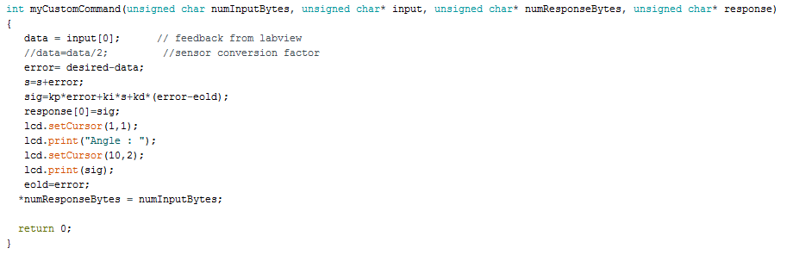

Communication and GUI

**For Simulation**

System model on solidworks

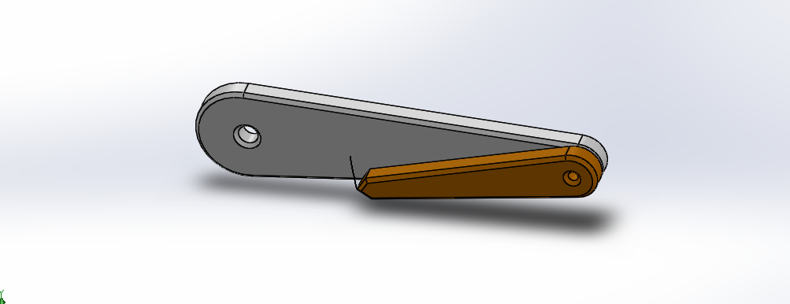

**For communication & GUI**

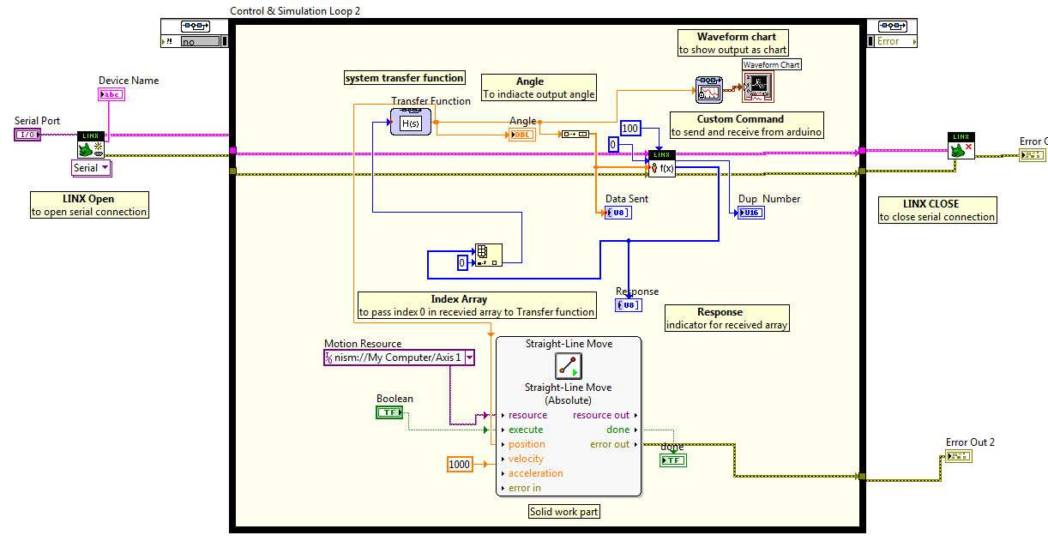We use MakerHub LINX for communication between labview



**Labview GUI**

**Hardware implementation** :

we add LCD part as Hardware to display the output :

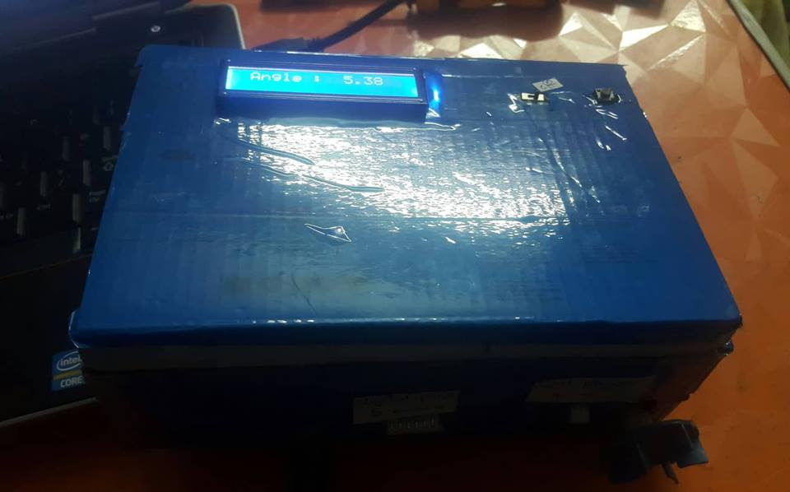

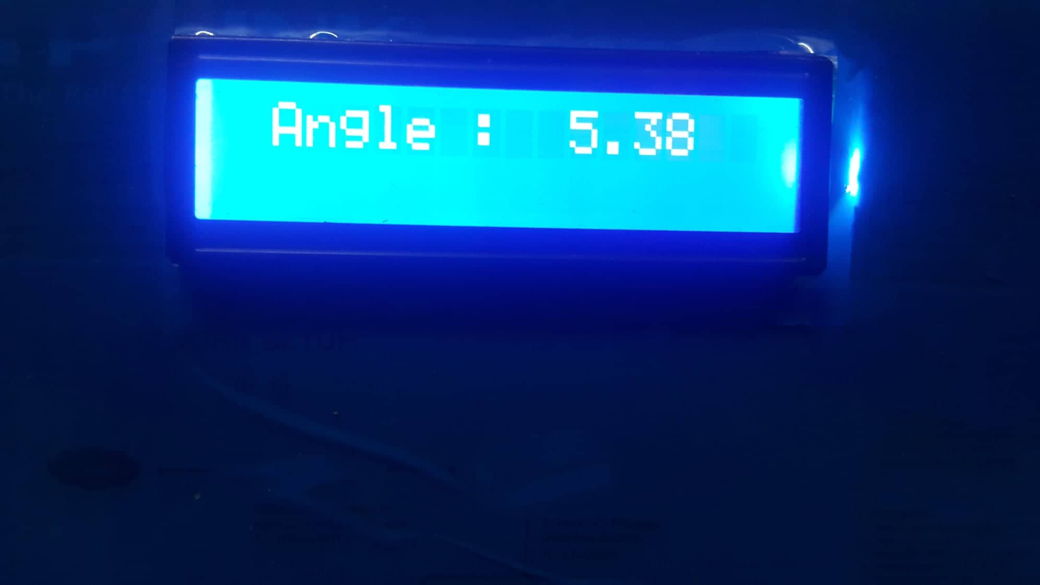

References :

1- Programming Arduino with Labview

2- labview makerHub community "https://www.labviewmakerhub.com/doku.php?id=learn:tutorials:libraries:linx:misc:adding_custom_command"

3- Design of robotics knee "graduation project 2016"